# Remote Connection to SQL Server 2008 Express

If you’re trying to connect to SQL Server 2008 Express remotely without enable remote connection first, you may see these error messages:

* **“Cannot connect to *SQL-Server-Instance-Name*  
  An error has occurred while establishing a connection to the server. When connecting to SQL Server 2005, this failure may be caused by the fact that under the default settings SQL Server does not allow remote connections. (provider: SQL Network Interfaces, error: 28 - Server doesn’t support requested protocol) (Microsoft SQL Server)”**  
  [Server doesn't support requested protocol](http://www.linglom.com/images/Windows/Programming/SQLServer/Enable-Remote-SQL-2008/1.png)
* **“Cannot connect to *SQL-Server-Instance-Name*  
  An error has occurred while establishing a connection to the server. When connecting to SQL Server 2005, this failure may be caused by the fact that under the default settings SQL Server does not allow remote connections. (provider: SQL Network Interfaces, error: 26 - Error Locating Server/Instance Specified) (Microsoft SQL Server)”**  
  [Error Locating Server/Instance Specified](http://www.linglom.com/images/Windows/Programming/SQLServer/Enable-Remote-SQL-2008/2.png)
* **“Cannot connect to *SQL-Server-Instance-Name*  
  Login failed for user ‘*username*‘. (Microsoft SQL Server, Error: 18456)”**  
  [Login failed for user 'sa'](http://www.linglom.com/images/Windows/Programming/SQLServer/Enable-Remote-SQL-2008/3.png)

To enable remote connection on SQL Server 2008 Express, see the step below:

1. Start SQL Server Browser service if it’s not yet started. SQL Server Browser listens for incoming requests for Microsoft SQL Server resources and provides information about SQL Server instances installed on the computer.
2. Enable TCP/IP protocol for SQL Server 2008 Express to accept remote connection.
3. **(Optional)** Change Server Authentication to SQL Server and Windows Authentication. By default, SQL Server 2008 Express allows only Windows Authentication mode so you can connect to the SQL Server with current user log-on using credentials. If you want to a specify user to connect to SQL Server, you have to change Server Authentication to SQL Server and Windows Authentication.

***Note:*** In SQL Server 2008 Express, there is no **SQL Server Surface Area Configuration** so configure it from **SQL Server Configuration Manager** instead.

1. Open SQL Server Configuration Manager. Click **Start** -> **Programs** -> **Microsoft SQL Server 2008** -> **Configuration Tools** -> **SQL Server Configuration Manager**.  
   [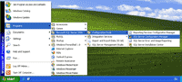](http://www.linglom.com/images/Windows/Programming/SQLServer/Enable-Remote-SQL-2008/4.png)
2. On SQL Server Configuration Manager, select **SQL Server Services** on the left window. If the state on SQL Server Browser is not running, you have to configure and start the service. Otherwise, you can skip to step 6.  
   [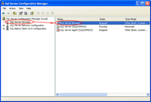](http://www.linglom.com/images/Windows/Programming/SQLServer/Enable-Remote-SQL-2008/5.png)
3. Double-click on SQL Server Browser, the Properties window will show up. Set the account for start **SQL Server Browser Service**. In this example, I set to **Local Service** account.  
   [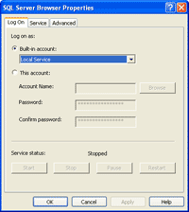](http://www.linglom.com/images/Windows/Programming/SQLServer/Enable-Remote-SQL-2008/6.png)
4. On SQL Server Browser Properties, move to **Service** tab and change **Start Mode** to **Automatic**. Therefore, the service will be start automatically when the computer starts. Click **OK** to apply changes.  
   [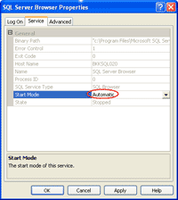](http://www.linglom.com/images/Windows/Programming/SQLServer/Enable-Remote-SQL-2008/7.png)
5. Back to SQL Server Configuration Manager, right-click on **SQL Server Bowser** on the right window and select **Start** to start the service.  
   [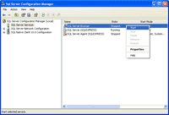](http://www.linglom.com/images/Windows/Programming/SQLServer/Enable-Remote-SQL-2008/8.png)
6. On the left window, expand **SQL Server Network Configuration** -> **Protocols for SQLEXPRESS**. You see that TCP/IP protocol status is disabled.  
   [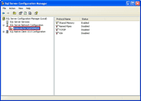](http://www.linglom.com/images/Windows/Programming/SQLServer/Enable-Remote-SQL-2008/9.png)
7. Right-click on **TCP/IP** and select **Enable** to enable the protocol.  
   [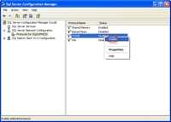](http://www.linglom.com/images/Windows/Programming/SQLServer/Enable-Remote-SQL-2008/10.png)
8. There is a pop-up shown up that you have to restart the SQL Service to apply changes.  
   [Need to Restart SQL Server Service](http://www.linglom.com/images/Windows/Programming/SQLServer/Enable-Remote-SQL-2008/11.png)
9. On the left window, select **SQL Server Services**. Select **SQL Server (SQLEXPRESS)** on the right window -> click **Restart**. The SQL Server service will be restarted.  
   [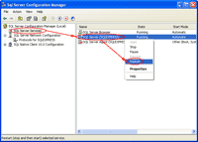](http://www.linglom.com/images/Windows/Programming/SQLServer/Enable-Remote-SQL-2008/12.png)
10. Open Microsoft SQL Server Management Studio and connect to the SQL Server 2008 Express.  
    [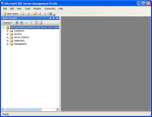](http://www.linglom.com/images/Windows/Programming/SQLServer/Enable-Remote-SQL-2008/13.png)
11. Right-click on the SQL Server Instance and select **Properties**.  
    [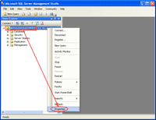](http://www.linglom.com/images/Windows/Programming/SQLServer/Enable-Remote-SQL-2008/14.png)
12. On Server Properties, select **Security** on the left window. Then, select **SQL Server and Windows Authentication** mode.  
    [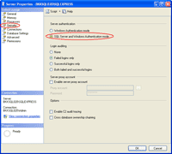](http://www.linglom.com/images/Windows/Programming/SQLServer/Enable-Remote-SQL-2008/15.png)
13. Again, there is a pop-up shown up that you have to restart the SQL Service to apply changes.  
    [Need to Restart SQL Server Service](http://www.linglom.com/images/Windows/Programming/SQLServer/Enable-Remote-SQL-2008/16.png)
14. Right-click on the SQL Server Instance and select **Restart**.  
    [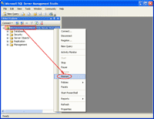](http://www.linglom.com/images/Windows/Programming/SQLServer/Enable-Remote-SQL-2008/17.png)
15. That’s it. Now you should be able to connect to the SQL Server 2008 Express remotely.